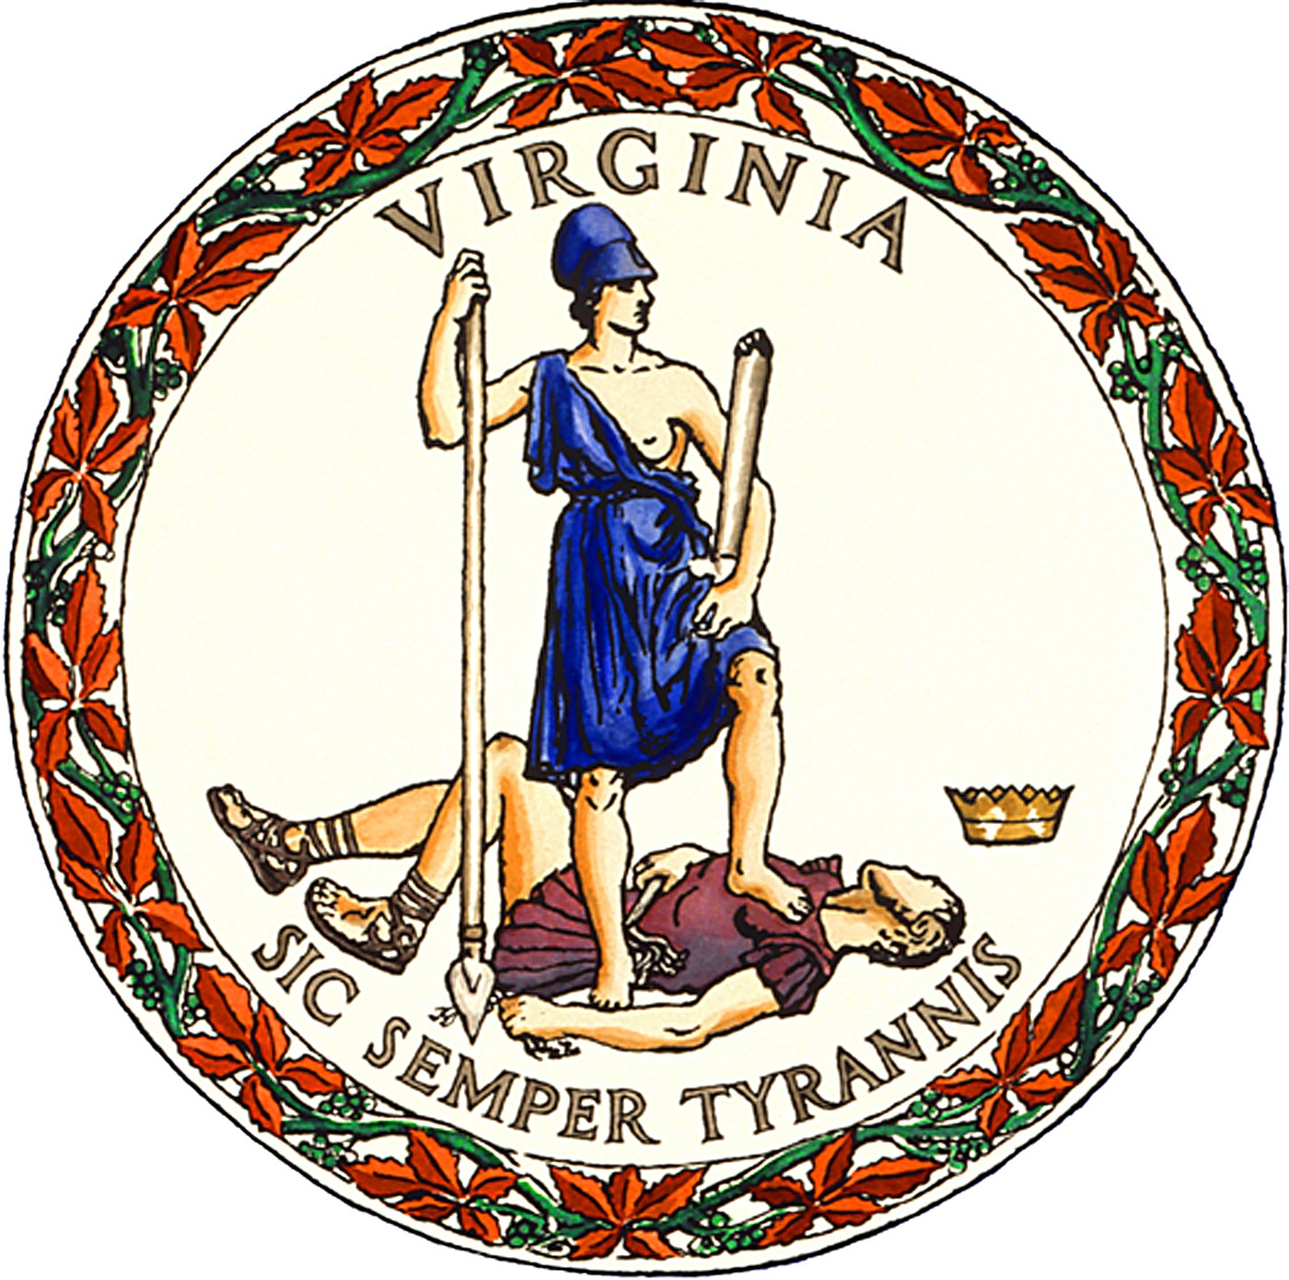

PUBLIC NOTICE
for the
November 7, 2023, General Election
in
Alleghany County, Virginia

In-Person Early Voting for Alleghany County voters will be available at the location, dates and hours listed below beginning Friday, September 22, 2023 and ending Saturday, November 4, 2023.
- 110 Rosedale Ave., 1st Floor, Covington, VA 24426 Monday-Friday 9:00 AM - 5:00 PM. Closed 1:00 PM – 2:00 PM for lunch
- This office will also be open on following Saturdays October 28th & November 4th from 9:00 AM - 5:00 PM. Closed 1:00 PM – 2:00 PM for lunch

Ballot dropboxes will be available from Friday, September 22, 2023, through Monday, November 13, 2023 at the address listed above until 12:00 P.M. Drop boxes will also be available at all polling places on Election Day, Tuesday, November 7, 2023, from 6:00 AM until 7:00 PM.

Tiney K. Rose
Director of Elections & Registrar
Posted: August 16, 2023

Va. Code §§ 24.2-701.2(E), -707.1(C)

