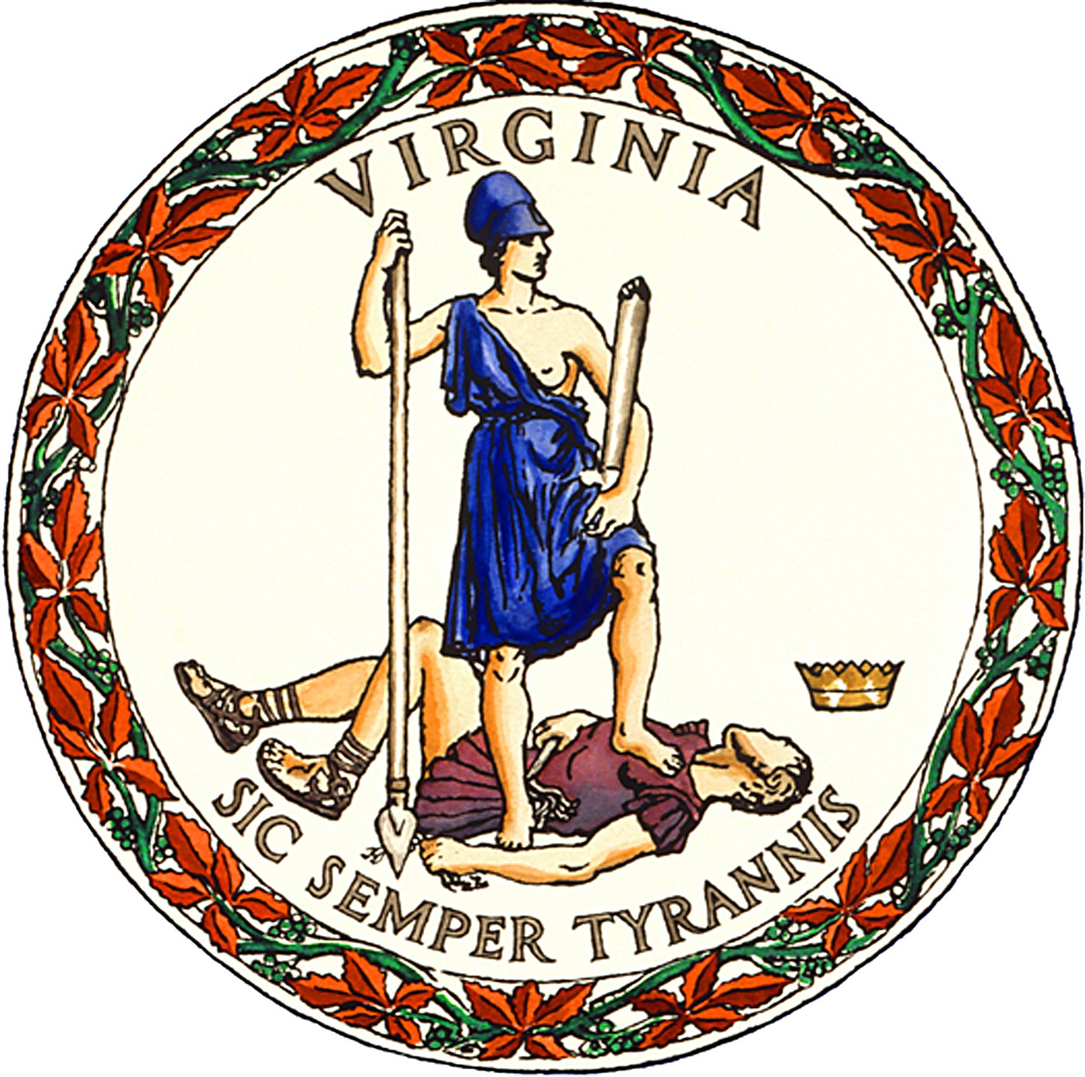

PUBLIC NOTICE
for the
Tuesday, June 8, 2021
Democratic Party Primary Election
In
Alleghany County, Virginia

In-Person Early Voting: for Alleghany County voters will be available at the location, dates and hours listed below:
Location: 110 Rosedale Ave., Ste. D, Covington, VA 24426
Beginning: Friday, April 23, 2021
Ending: Saturday, June 5, 2021
Hours: 9:00 AM – 5:00 PM
Saturdays: May 29 & June 5, 2021

Ballot Dropbox - will be available at the main entrance to the building at the address listed above on the outside wall to deposit your voted and packaged ballot into. You have until Tuesday, June 8, 2021 @ 7:00 PM to drop off your ballot in this drop box. In addition, drop boxes will be available at all regular polling places on Election Day – Tuesday, June 8th from 6:00 AM until 7:00 PM.

Tiney K. Rose – VREO, CGRV
General Registrar / Director of Elections
Posted: April 13, 2021

Va. Code § 24.2-701.2(E)

